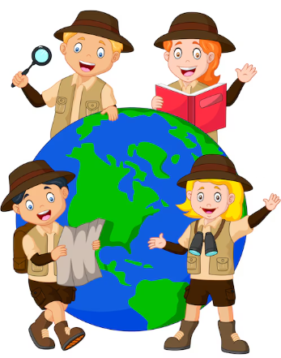

**Years 1&2: Explorers**

**How can we explore God’s world without upsetting the environment?**

**Years 3&4: Earth Matters**

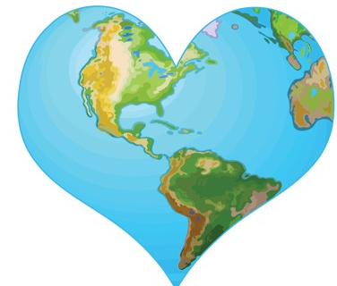

**How can we tend to God’s Earth so we leave it in a better state than it is in now?**

**Years 5&6: Space**

**One small step - What is our next giant leap in protecting God’s creation?**

